**Experiment:**

**Section 1 : Point sampling of a sinusoid**

Part a:

Plot generated:

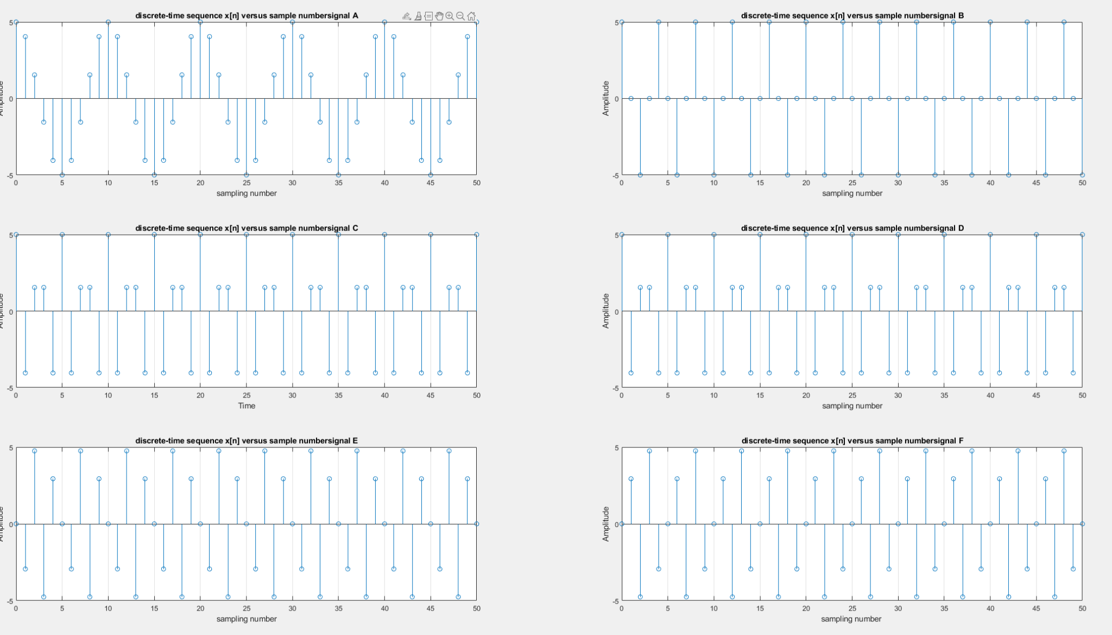

**Part b:**

the period of each of Continuous-Time Periods signals can be determined by 1/frequency of each signals:

A: 1/10Hz = 0.1

B: 1/25Hz = 0.04

C: 1/40Hz = 0.025

D: 1/60Hz = 0.0167

E: 1/40Hz = 0.025

F: 1/60Hz = 0.0167

Visually determine the period of each of the discrete-time signals:

A: 0.1

B: 0.04

C: 0.05

D: 0.05

E: 0.05

F: 0.05

**Discussion:**

From above comparison we can found out that signal A,B,C,E ‘ period is identical with discrete-time or Continuous-Time. This is due to the fact that the sampling rate is 100Hz. According to the Nyquist sampling theorem, as long as Fs max >= 2* f0, we can guarantees that the discrete samples capture the frequency content of the original continuous-time signals without distortion.

Thats is also the reason why signals D and F ‘ discrete-time period does not match with their Continuous-Time Periods, because they have a frequency of 60 Hz, we need at least 2 * 60 Hz = 120Hz to sampling them without distortion.

**Part c:**

Case C: no impact

Case D: no impact

Case E: The signal is shifted to the right (delayed) by pi/2 radians.

Case F: The signal is shifted to the right (delayed) by pi/2 radians.

**Section 2 : Working with unit impulses and unit steps**

**Part a:**

**Plot:**

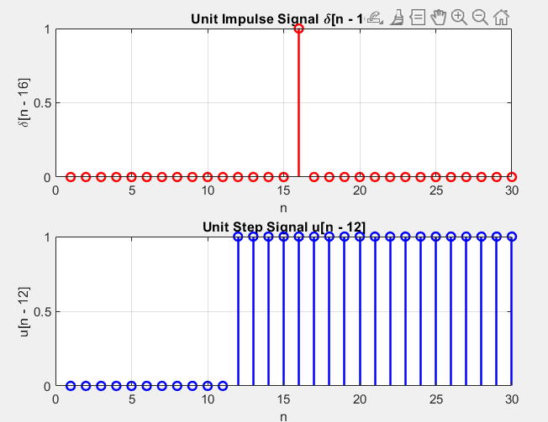

**Part b:**

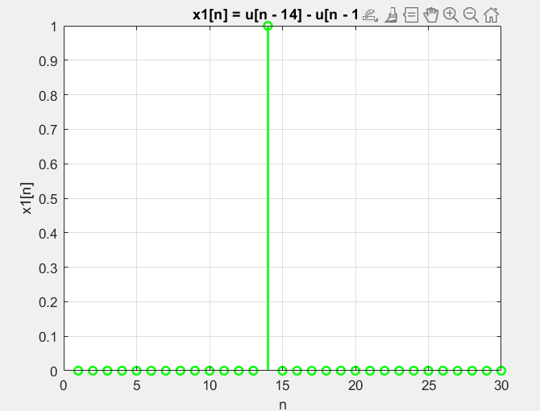

From the plot, if we interpret this signal as [n − k], the value of K is 14. Since when when n is 1 the value of the function should be 1.

**Part c:**

Plot:

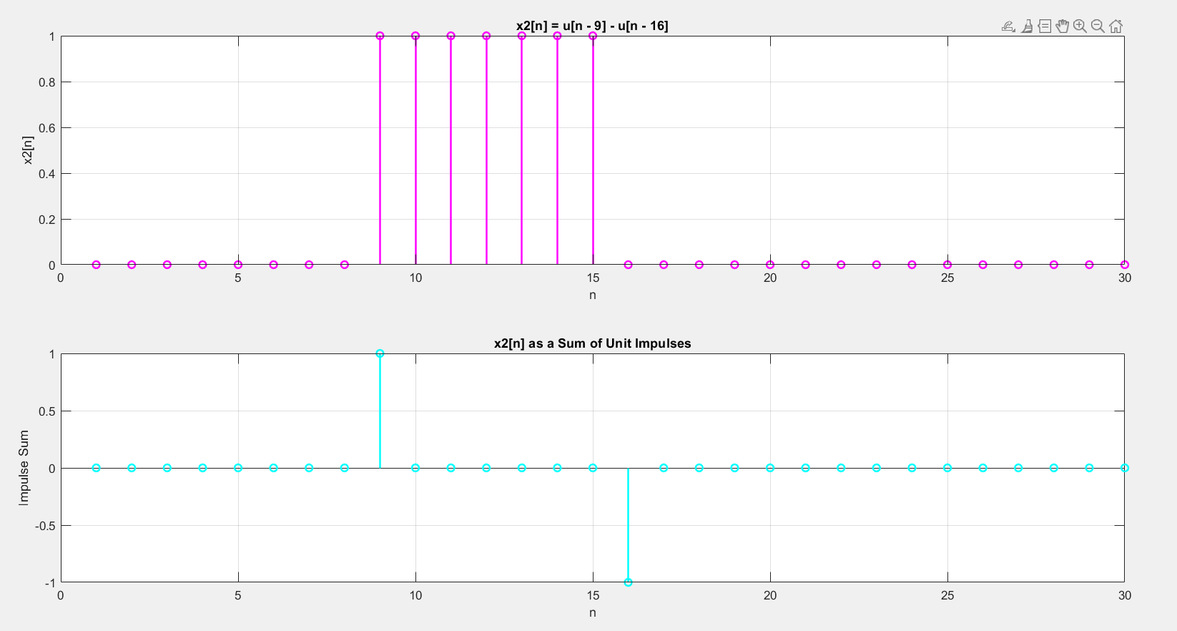

From the plot we can tell that the width of the resulting rectangular “pulse” is 7 since we have 7 points here; 9, 10, 11, 12, 13, 14, 15

**Section 3 Complex signals:**

**Part a :**

**Plot:**

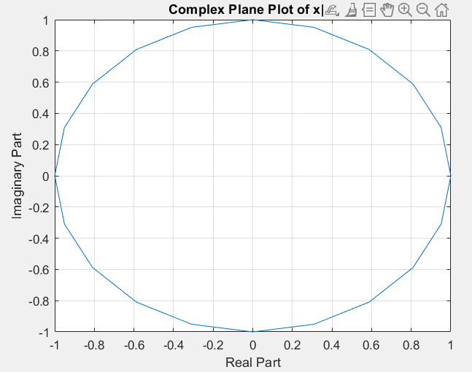

**Part b :**

**Plot:**

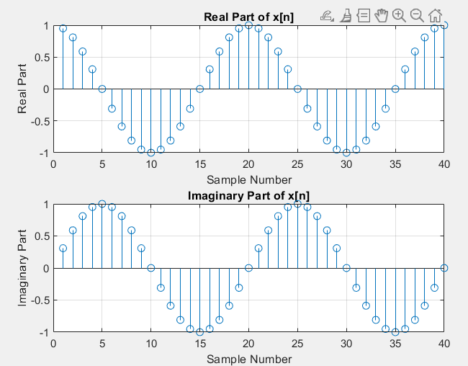

**Part c :**

**plot:**

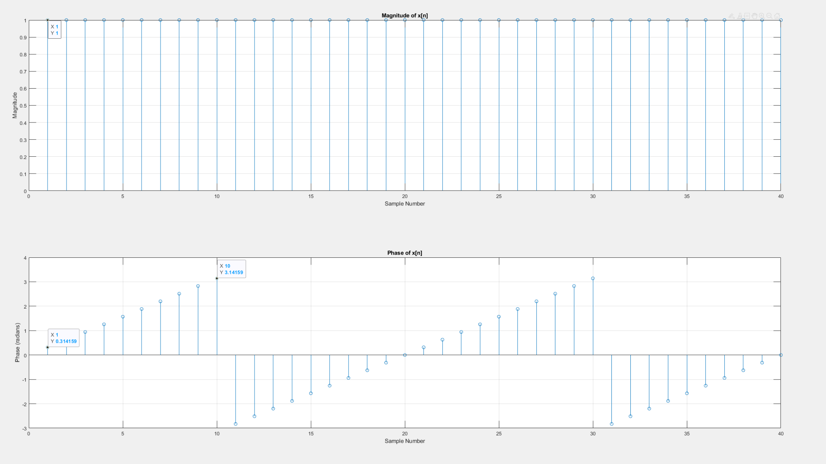

Discussion:

The plot of magnitude make sense as the magnitude of complex number as Ae^(j *omega *n) can be calculated as follow:

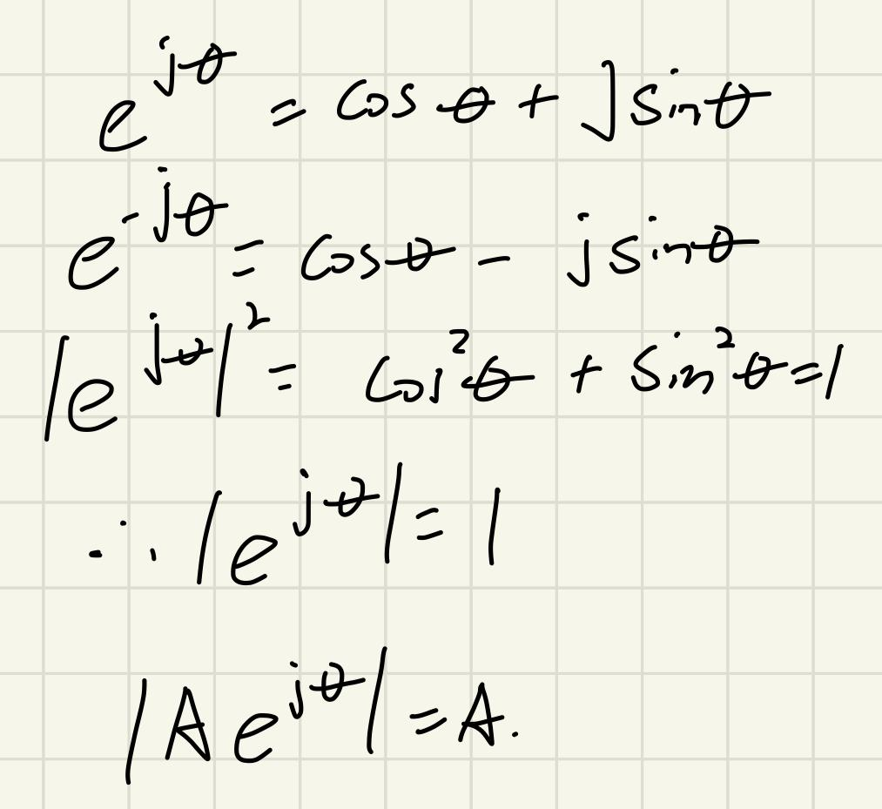

The slope in this plot is π/10, which aligns with the parameters used to create the signal.

The amplitude of a complex signal that remains steady at 1 (A = 1) and as the result; the angular frequency used to generate x[n] is equal to the slope of the phase vs. number of samples curve, which is π/10.

The reason for this is that the phase of a complex exponential signal increases at a linear rate over time, and the angular frequency is equal to the slope of the phase.

**Section 4 Quantization of a speech signal:**

**Part b :**

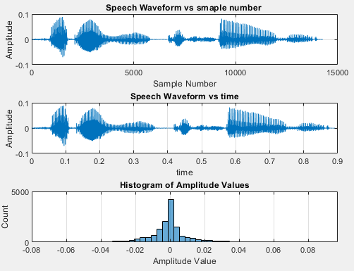

**Discussion:**

The speech signal was quantized using 16 bits per sample.

Also from the Histogen plot we can tell that the distribution of amplitude value is normal where there are more data point close to zero. Because from the waveform, we can see there are lots of time the audio is silence.

**Part c discussion :**

The quality of the audio is clear; I can easily figure out what is saying.

**Part f :**

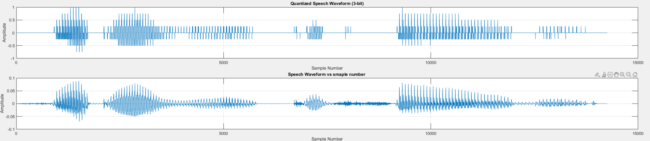

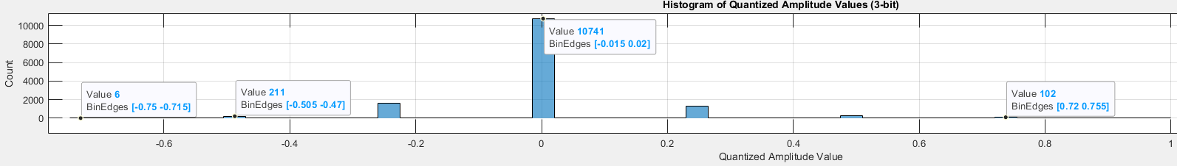

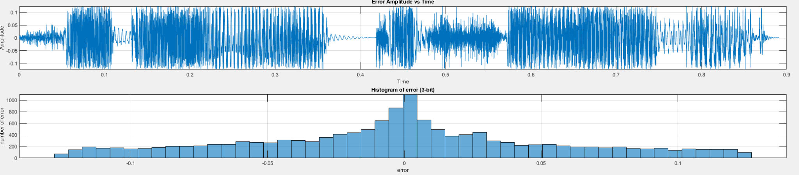

**Discussion:**

The speech signal was quantized using 16 bits per sample.

From the Histogram Of Quantized Amplitude Value plot, it is evident that the amplitude value distribution closely resembles a normal distribution, with a higher concentration of data points around zero. However, due to our utilization of three bits quantizer (resulting in eight bins) for signal sampling, the histogram displays the amplitude values within discrete bins, as opposed to The continuous format observed in part b. Additionally, it's worth noting that, in conjunction with the scale used, the amplitude values in this case are ten times larger than those in part b.

Looking at the Error Amplitude vs Sample number and Histogram of error (3-bit), we can clearly see that there are more error located close to origin; the reason for that is in the original signal, there are big chunk of signal is close to silence which is close to 0 in the amplitude, but in 3 bit quantizer, there are no such thing called close to 0, all signal parts that are close to silence fall into the zero bins which is the reason why there are so many 0 bin count in the Histogram of Quantized Amplitude Values (3-bit) plot as well.

The histogen has the behavior of normal distribution which is expected, beside the reason above, since we set our bin and step of this bin evenly, having normal distribution is the right behavior.

The quality of the audio is getting distorted slightly, but I can still figure out what is saying. Sound like a voice through phone.

**Part g :**

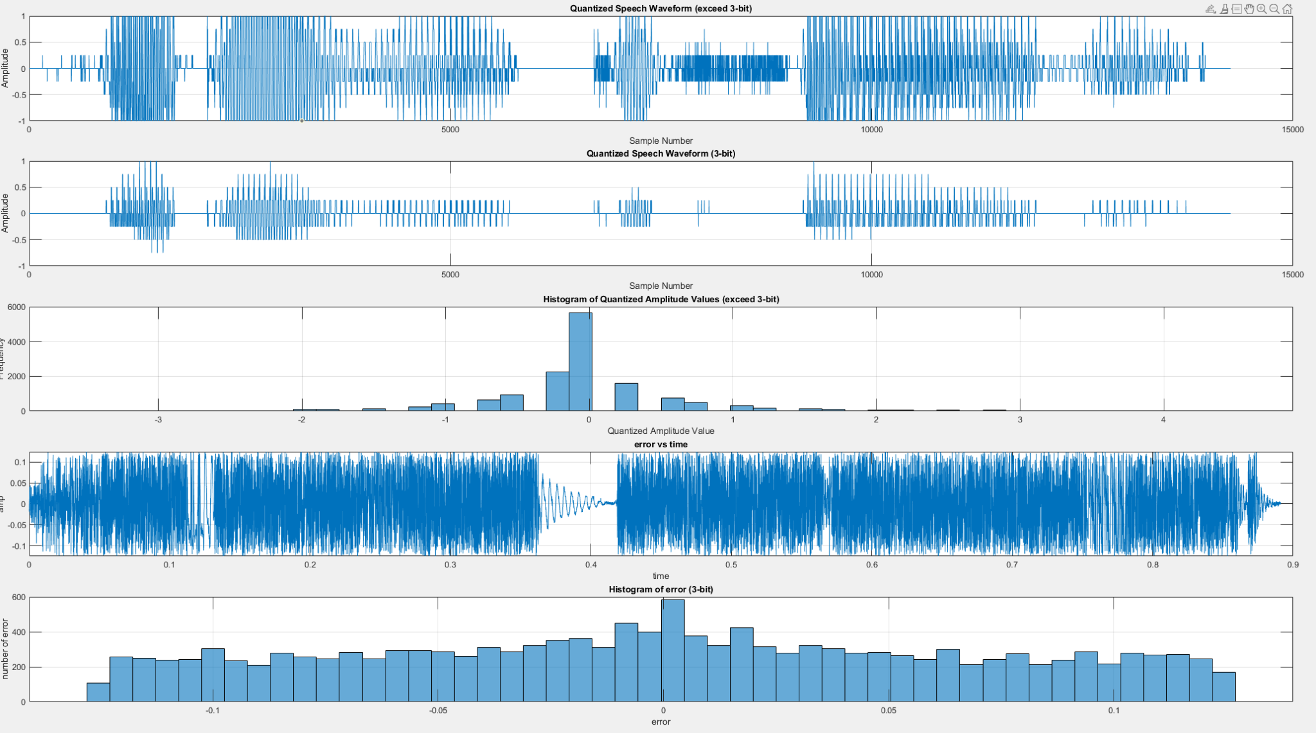

**Discussion:**

The speech signal was quantized using 16 bits per sample.

To surpass the maximum scale range of the 3-bit quantizer, I applied a scaling factor of 50. The outcome is readily apparent: since we've exhausted the available bins for representing all the data points in the original signal, the quantized waveform lacks a significant amount of detail compared to the original signal. As a result, this deficiency is also reflected in the histogram.

The problem of exceeding 8 bin quantizer also reflected on Histogram of Quantized Amplitude Values (exceed 3-bit) plot where we can see there are way more bins than 8 bins that we only have. As the result, the histogram of error is evenly distributed cross the whole range.

The quality of the audio is distorted heavily, I can not figure out what is saying.